FIGURE I - PROPORTION OF INFORMAL WORKERS (%)

SOURCE: OWN ELABORATION – PNAD DATA (1992-2012)

FIGURE II - PROPORTION OF INFORMAL WORKERS BY SEX (%)

SOURCE: OWN ELABORATION – PNAD DATA (1992-2012)

FIGURE III - PROPORTION OF INFORMAL WORKERS BY ETHNICITY (%)

|  |
| --- |
|  |

SOURCE: OWN ELABORATION – PNAD DATA (1992-2012)

FIGURE IV - PROPORTION OF INFORMAL WORKERS BY URBAN \ RURAL (%)

SOURCE: OWN ELABORATION – PNAD DATA (1992-2012)

FIGURE V - KAPLAN-MEIER SURVIVAL ESTIMATES BY SEX

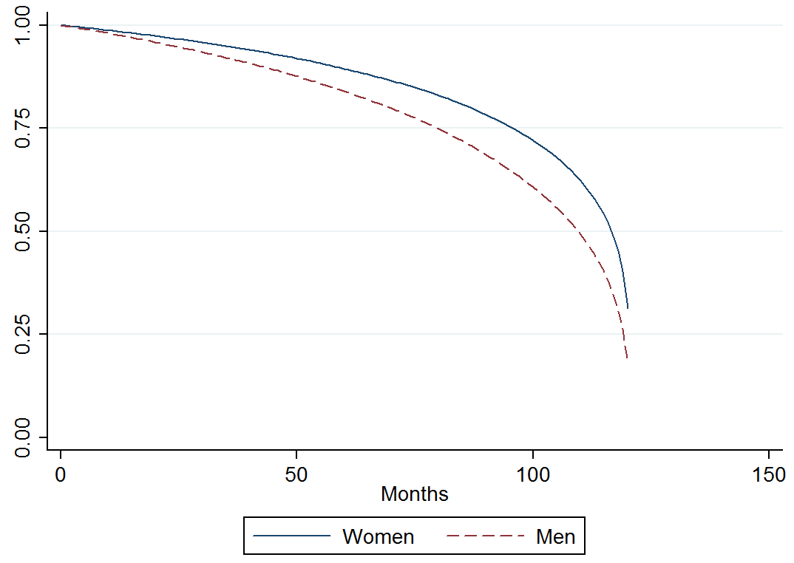

SOURCE: OWN ELABORATION

FIGURE VI - KAPLAN-MEIER SURVIVAL ESTIMATES BY YEARS OF SCHOOLING

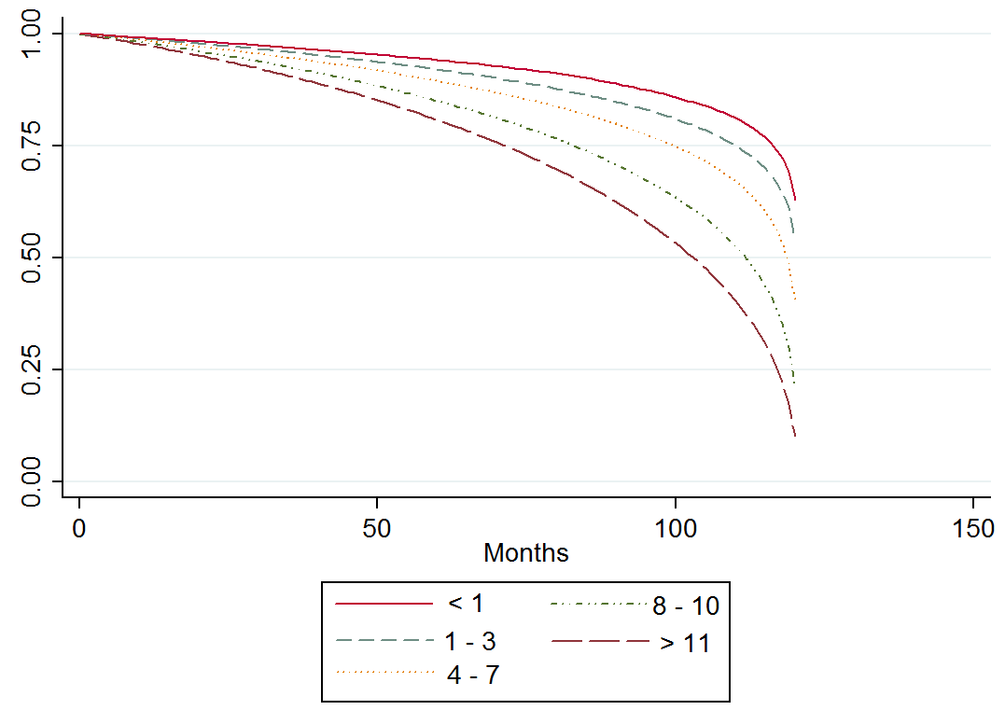

SOURCE: OWN ELABORATION

FIGURE VII - KAPLAN-MEIER SURVIVAL ESTIMATES BY AGE

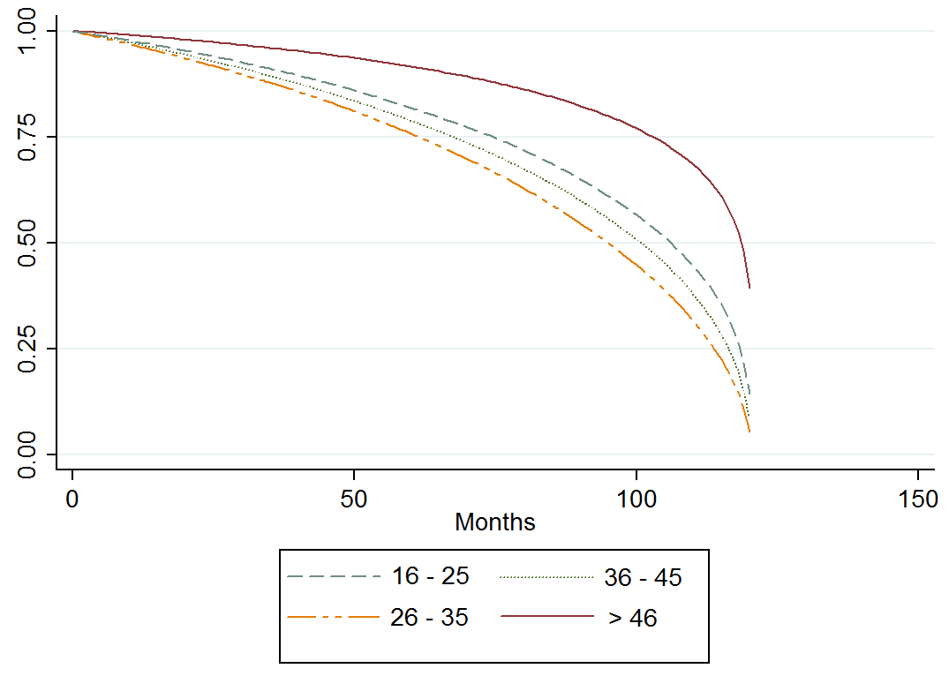

SOURCE: OWN ELABORATION

FIGURE VIII - KAPLAN-MEIER SURVIVAL ESTIMATES BY ETHNICITY

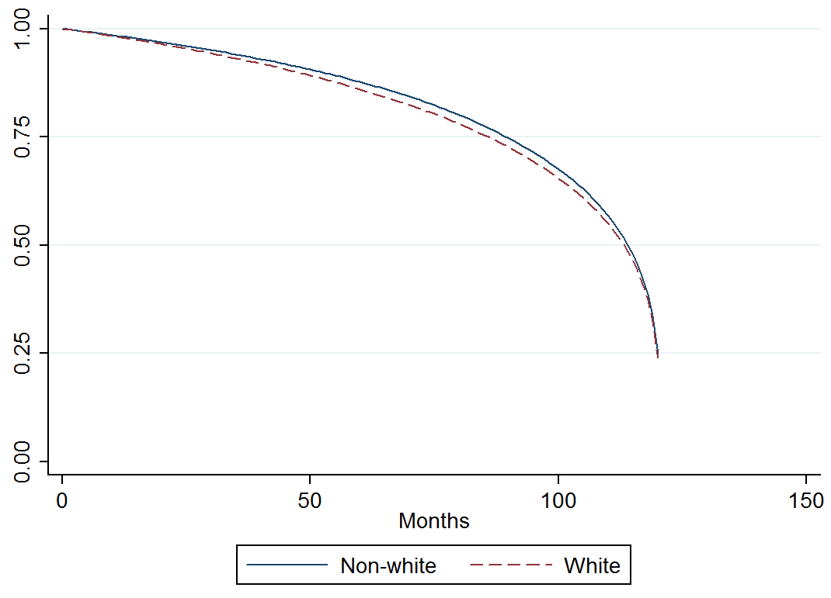

SOURCE: OWN ELABORATION

FIGURE IX - KAPLAN-MEIER SURVIVAL ESTIMATES BY CONDITION IN THE HOUSEHOLD

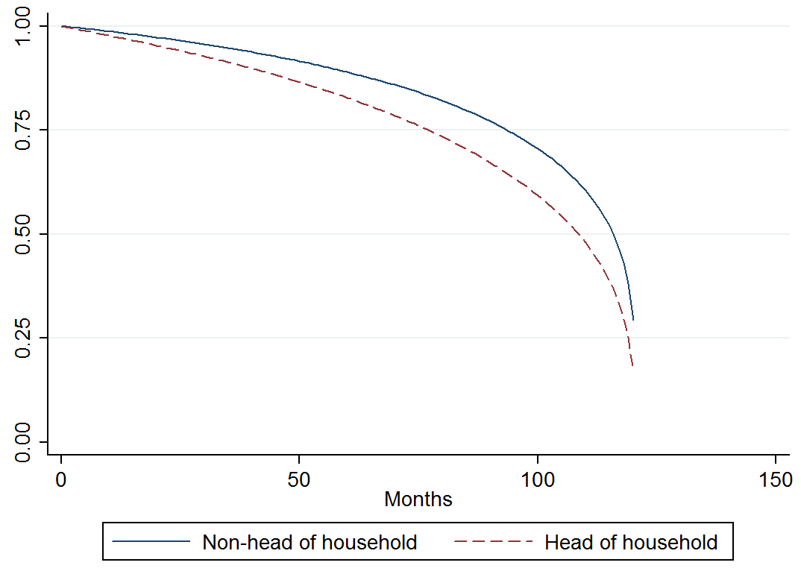

SOURCE: OWN ELABORATION

FIGURE X - KAPLAN-MEIER SURVIVAL ESTIMATES BY METROPOLITAN CITIES

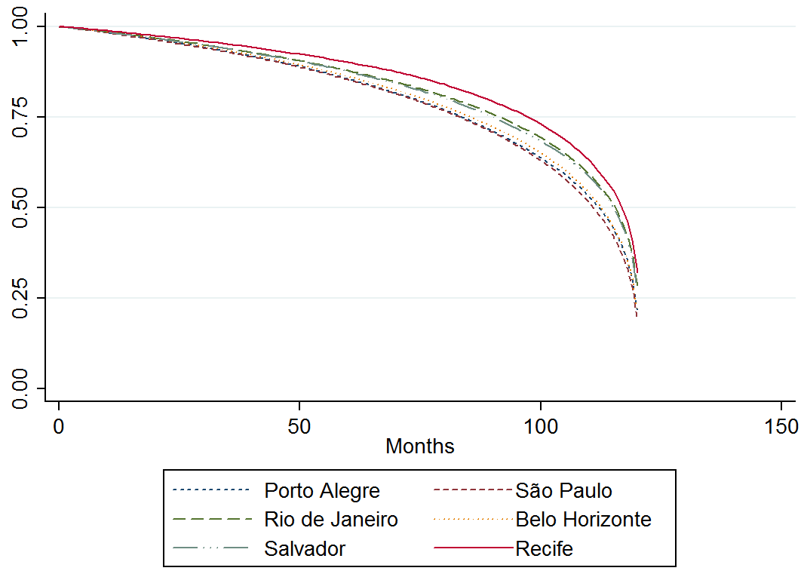

SOURCE: OWN ELABORATION

FIGURE XI - KAPLAN-MEIER SURVIVAL ESTIMATES BY SECTOR OF ACTIVITY

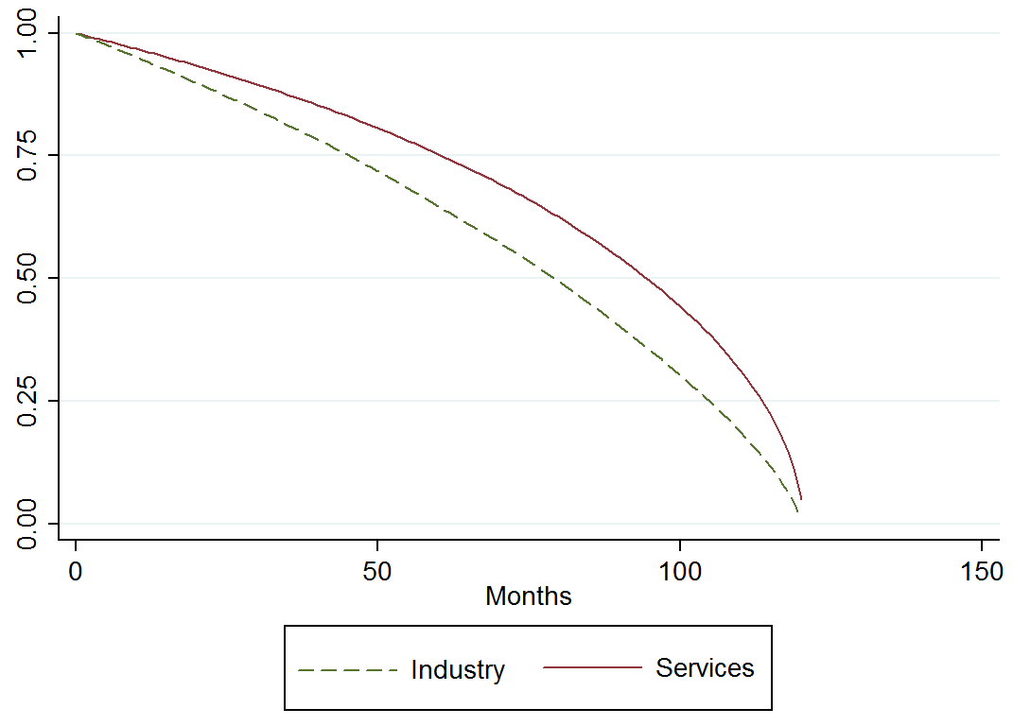

SOURCE: OWN ELABORATION

FIGURE XII - ADEQUACY TEST

SOURCE: OWN ELABORATION

TABLE 1 - PROPORTION OF INFORMAL WORKERS BY LEVEL STUDY COMPLETED (%)

|  |  |  |  |  |  |  |  |  |  |  |  |  |  |  |  |  |  |  |  |  |  |  |  |  |  |  |  |  |  |  |  |  |  |  |  |  |  |  |  |  |  |  |  |  |  |  |  |  |  |  |  |  |  |  |  |  |  |  |  |  |  |  |  |  |  |  |  |  |  |  |  |  |  |  |  |  |  |  |  |  |  |  |  |  |  |  |  |  |  |  |  |  |  |  |  |  |  |  |  |  |  |  |  |  |  |  |  |  |  |  |  |  |  |  |
| --- | --- | --- | --- | --- | --- | --- | --- | --- | --- | --- | --- | --- | --- | --- | --- | --- | --- | --- | --- | --- | --- | --- | --- | --- | --- | --- | --- | --- | --- | --- | --- | --- | --- | --- | --- | --- | --- | --- | --- | --- | --- | --- | --- | --- | --- | --- | --- | --- | --- | --- | --- | --- | --- | --- | --- | --- | --- | --- | --- | --- | --- | --- | --- | --- | --- | --- | --- | --- | --- | --- | --- | --- | --- | --- | --- | --- | --- | --- | --- | --- | --- | --- | --- | --- | --- | --- | --- | --- | --- | --- | --- | --- | --- | --- | --- | --- | --- | --- | --- | --- | --- | --- | --- | --- | --- | --- | --- | --- | --- | --- | --- | --- | --- | --- |
| |  |  |  |  |  |  | | --- | --- | --- | --- | --- | --- | |  | Illiterate | Element | Primary | Second. | Higher | | 1992 | 84.17 | 58.62 | 40.69 | 24.50 | 12.88 | | 1993 | 85.59 | 59.25 | 42.77 | 25.47 | 13.81 | | 1995 | 84.88 | 60.65 | 44.18 | 27.52 | 14.75 | | 1996 | 83.84 | 60.11 | 44.20 | 29.29 | 16.84 | | 1997 | 84.48 | 61.59 | 45.29 | 29.48 | 18.27 | | 1998 | 85.05 | 62.55 | 47.09 | 31.55 | 19.43 | | 1999 | 86.52 | 64.35 | 49.77 | 32.58 | 19.12 | | 2001 | 85.28 | 65.24 | 51.04 | 34.43 | 21.39 | | 2002 | 85.46 | 66.81 | 53.99 | 36.14 | 22.15 | | 2003 | 85.52 | 66.58 | 55.06 | 35.20 | 21.45 | | 2004 | 85.94 | 67.73 | 55.32 | 35.22 | 21.18 | | 2005 | 85.65 | 67.60 | 55.09 | 35.45 | 21.62 | | 2006 | 85.49 | 67.00 | 55.29 | 35.37 | 21.64 | | 2007 | 84.96 | 65.99 | 55.05 | 34.89 | 21.36 | | 2008 | 84.51 | 64.93 | 54.88 | 34.55 | 22.49 | | 2009 | 84.19 | 64.82 | 54.12 | 34.17 | 21.09 | | 2011 | 83.05 | 61.18 | 48.90 | 30.65 | 19.16 | | 2012 | 82.34 | 59.75 | 48.33 | 30.16 | 19.62 | |

SOURCE: OWN ELABORATION - PNAD DATA (1992-2012)

TABLE 2 - DESCRIPTIVE STATISTICS

|  |  |  |  |  |  |
| --- | --- | --- | --- | --- | --- |
|  | | Transition | | General | |
| Variable | Mean | | Std.Dev. | Mean | Std.Dev. |
| ***Sex*** |  | |  |  |  |
| Man | 0.571 | | 0.495 | 0.470 | 0.499 |
| Woman | 0.429 | | 0.495 | 0.530 | 0.499 |
| ***Ethnicity*** |  | |  |  |  |
| White | 0.514 | | 0.500 | 0.499 | 0.499 |
| Non-white | 0.486 | | 0.500 | 0.501 | 0.499 |
| ***Household head*** |  | |  |  |  |
| Yes | 0.436 | | 0.496 | 0.325 | 0.468 |
| No | 0.564 | | 0.496 | 0.675 | 0.468 |
| ***Age group*** |  | |  |  |  |
| 16-25 | 0.225 | | 0.418 | 0.222 | 0.377 |
| 26-35 | 0.324 | | 0.468 | 0.211 | 0.370 |
| 36-45 | 0.247 | | 0.431 | 0.192 | 0.356 |
| >46 | 0.202 | | 0.402 | 0.374 | 0.453 |
| ***Schooling*** |  | |  |  |  |
| <1 | 0.012 | | 0.109 | 0.043 | 0.184 |
| 1 - 3 | 0.032 | | 0.175 | 0.064 | 0.252 |
| 4 -7 | 0.174 | | 0.379 | 0.240 | 0.433 |
| 8 - 10 | 0.180 | | 0.384 | 0.194 | 0.368 |
| >11 | 0.600 | | 0.490 | 0.455 | 0.478 |
| ***Metropolitan area*** | | |  |  |  |
| Recife | 0.104 | | 0.305 | 0.136 | 0.344 |
| Salvador | 0.110 | | 0.312 | 0.121 | 0.326 |
| Belo Horizonte | 0.213 | | 0.410 | 0.195 | 0.396 |
| Rio de Janeiro | 0.165 | | 0.371 | 0.180 | 0.384 |
| São Paulo | 0.242 | | 0.429 | 0.216 | 0.412 |
| Porto Alegre | 0.166 | | 0.372 | 0.152 | 0.359 |
| ***Economic sector*** | | |  |  |  |
| Industry | 0.215 | | 0.408 | 0.160 | 0.258 |
| Services | 0.785 | | 0.410 | 0.840 | 0.484 |

SOURCE: OWN ELABORATION – PME DATA (2004-2013)

TABLE 3 - AIC SCORES

|  |  |
| --- | --- |
| Model | AIC |
| Exponential | 1,987,823 |
| Weibull | 1,563,169 |
| Gompertz | 1,783,905 |
| Lognormal | 1,902,837 |
| Loglogistic | 1,820,558 |
| Gamma | 1,766,411 |

SOURCE: OWN ELABORATION

TABLE 4 - PARAMETRIC RESULTS (HAZARD RATIOS)

|  |  |
| --- | --- |
| Variables | Hazard Ratios |
| man | 1.297 *** |
| sch<1 | Reference |
| sch1_3 | 4.048 *** |
| sch4_7 | 5.050 *** |
| sch8_10 | 6.362 *** |
| sch>11 | 8.760 *** |
| age1625 | 2.515 *** |
| age2635 | 3.018 *** |
| age3645 | 2.635 *** |
| agemore46 | Reference |
| white | 0.916 *** |
| hhh | 1.332 *** |
| recife | Reference |
| sp | 3.283 *** |
| salvador | 0.431 *** |
| bh | 10.878 *** |
| rj | 8.320 *** |
| poa | 15.973 *** |
| serv | Reference |
| ind | 2.145 *** |
| constant | 0.001 *** |

SOURCE: OWN ELABORATION

Significance levels: *10 percent, **5 percent, ***1 percent

TABLE A1 - DESCRIPTION OF SELECTED VARIABLES

|  |  |  |
| --- | --- | --- |
| Variable | Description | Obs |
| forminf | 1= formal worker; 0= informal worker | Transition var. |
| man | 1= man; 0= woman |  |
| age1625 | 1= age between 16 and 25(included); 0= otherwise |  |
| age2635 | 1= age between 26 and 35(included); 0= otherwise |  |
| age3645 | 1= age between 36 and 45(included); 0= otherwise |  |
| agemore46 | 1= age more than 46(included); 0= otherwise | Ref. category |
| sch<1 | 1= schooling less than 1year; 0= otherwise | Ref. category |
| sch1_3 | 1= schooling between 1 and 3 years(included); 0= otherwise |  |
| sch4_7 | 1= schooling between 4 and 7 years(included); 0= otherwise |  |
| sch8_10 | 1= schooling between 8 and 10 years(included);0= otherwise |  |
| sch>11 | 1= schooling more than 11 years(included); 0= otherwise |  |
| white | 1= white; 0= non-white |  |
| hhh | 1= head of household; 0= otherwise |  |
| recife | 1= lives in metropolitan area of Recife; 0= otherwise | Ref. category |
| sp | 1= lives in metropolitan area of São Paulo; 0= otherwise |  |
| salvador | 1= lives in metropolitan area of Salvador; 0= otherwise |  |
| bh | 1= lives in metropolitan area of Belo Horizonte; 0= otherwise |  |
| rj | 1= lives in metropolitan area of Rio de Janeiro; 0= otherwise |  |
| poa | 1= lives in metropolitan area of Porto Alegre; 0= otherwise |  |
| serv | 1= employed in services sector; 0= otherwise | Ref. category |
| ind | 1= employed in industry sector; 0= otherwise |  |

SOURCE: OWN ELABORATION